**********DATA SUMMARY**********

SRs by month-year

MonthYear Count

2023-01 242157

2023-02 225012

2023-03 251747

2023-04 247476

2023-05 281055

2023-06 267238

2023-07 289374

2023-08 282824

2023-09 275631

Number of rows in the 311 SR data set: 2,362,514

Data contains SRs created from 2023-01-01 00:00:00 through 2023-09-30 23:59:58

Average monthly count is 262502 with a standard deviation of 21895

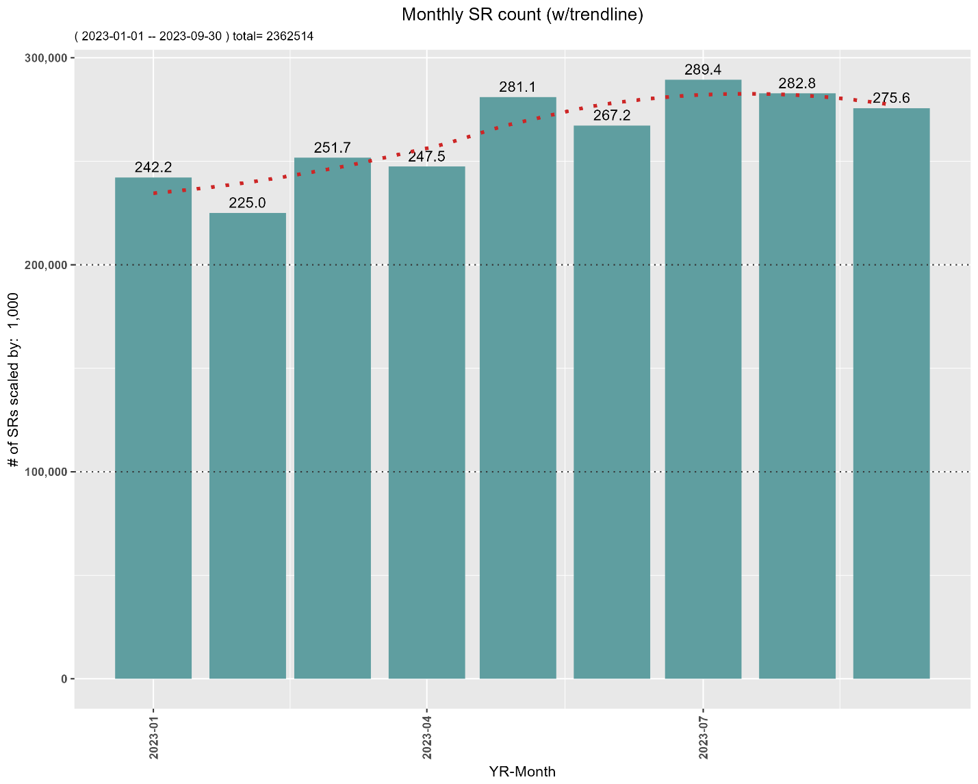

SRs by Agency

agency count percentage cumulative_percentage

NYPD 1044360 44.21 44.21

HPD 444050 18.80 63.01

DSNY 228398 9.67 72.68

DOT 150816 6.38 79.06

DEP 127835 5.41 84.47

DPR 104701 4.43 88.90

DOB 74811 3.17 92.07

DOHMH 66024 2.79 94.86

EDC 42902 1.82 96.68

DHS 34770 1.47 98.15

TLC 25439 1.08 99.23

DCWP 16210 0.69 99.92

DOE 1110 0.05 99.97

OTI 1088 0.05 100.02

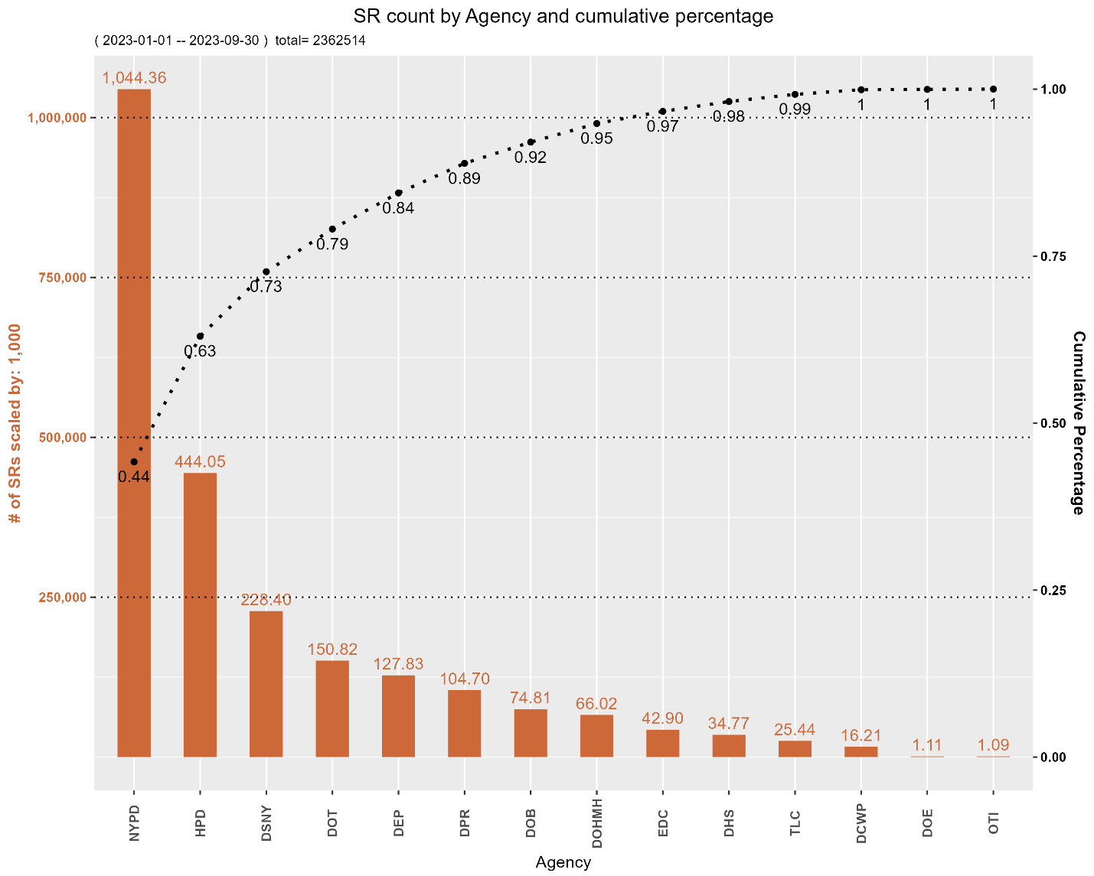

Top 15 'complaint_type' and responsible Agency (>1% occurrence):

complaint_type count percentage agency

ILLEGAL PARKING 351350 14.87 NYPD

NOISE - RESIDENTIAL 224613 9.51 NYPD

HEAT/HOT WATER 124459 5.27 HPD

NOISE - STREET/SIDEWALK 120063 5.08 NYPD

BLOCKED DRIVEWAY 119908 5.08 NYPD

UNSANITARY CONDITION 83589 3.54 HPD

STREET CONDITION 51430 2.18 DOT

ABANDONED VEHICLE 48862 2.07 NYPD

NOISE - COMMERCIAL 48470 2.05 NYPD

PLUMBING 47001 1.99 MULTIPLE

WATER SYSTEM 43472 1.84 MULTIPLE

MISSED COLLECTION 43003 1.82 DSNY

NOISE - HELICOPTER 42902 1.82 EDC

PAINT/PLASTER 42156 1.78 HPD

NOISE - VEHICLE 40903 1.73 NYPD

SRs by Status

status count percentage cumulative_percentage

CLOSED 2230973 94.43 94.43

IN PROGRESS 92171 3.90 98.33

OPEN 24769 1.05 99.38

ASSIGNED 8142 0.34 99.72

PENDING 4256 0.18 99.90

UNSPECIFIED 1163 0.05 99.95

STARTED 1040 0.04 99.99

**********BLANK, UNSPECIFIED, AND UNKNOWN ENTRIES BY COLUMN**********

Number and % blanks (incl 'NA'), UNSPECIFIED, and UNKNOWN entries per column:

field blanks pctBlank Unspecified pctUnspecified UNKNOWN pctUnknown

vehicle_type 2361956 99.98 0 0.00 0 0.00

taxi_company_borough 2361154 99.94 0 0.00 0 0.00

road_ramp 2357155 99.77 0 0.00 0 0.00

bridge_highway_direction 2354239 99.65 0 0.00 0 0.00

due_date 2354206 99.65 0 0.00 0 0.00

bridge_highway_name 2346808 99.34 0 0.00 0 0.00

bridge_highway_segment 2346802 99.33 0 0.00 0 0.00

taxi_pick_up_location 2337467 98.94 0 0.00 0 0.00

facility_type 2203543 93.27 0 0.00 0 0.00

landmark 910782 38.55 0 0.00 0 0.00

intersection_street_1 731807 30.98 0 0.00 0 0.00

intersection_street_2 730343 30.91 0 0.00 0 0.00

cross_street_1 627712 26.57 0 0.00 0 0.00

cross_street_2 626969 26.54 0 0.00 0 0.00

location_type 294197 12.45 0 0.00 0 0.00

bbl 287134 12.15 0 0.00 0 0.00

closed_date 127103 5.38 0 0.00 0 0.00

city 124619 5.27 0 0.00 1 0.00

street_name 94922 4.02 0 0.00 1 0.00

incident_address 94867 4.02 0 0.00 0 0.00

zip_codes 48816 2.07 0 0.00 0 0.00

resolution_description 48584 2.06 0 0.00 0 0.00

resolution_action_updated_date 41542 1.76 0 0.00 0 0.00

borough_boundaries 39482 1.67 0 0.00 0 0.00

community_districts 39480 1.67 0 0.00 0 0.00

city_council_districts 39480 1.67 0 0.00 0 0.00

police_precincts 39480 1.67 0 0.00 0 0.00

latitude 38928 1.65 0 0.00 0 0.00

longitude 38928 1.65 0 0.00 0 0.00

location 38928 1.65 0 0.00 0 0.00

x_coordinate_state_plane 38836 1.64 0 0.00 0 0.00

y_coordinate_state_plane 38124 1.61 0 0.00 0 0.00

descriptor 29041 1.23 0 0.00 0 0.00

incident_zip 28431 1.20 NA NA NA NA

address_type 12837 0.54 0 0.00 0 0.00

unique_key 0 0.00 0 0.00 0 0.00

created_date 0 0.00 0 0.00 0 0.00

agency 0 0.00 0 0.00 0 0.00

agency_name 0 0.00 0 0.00 0 0.00

complaint_type 0 0.00 0 0.00 0 0.00

status 0 0.00 1163 0.05 0 0.00

community_board 0 0.00 0 0.00 0 0.00

borough 0 0.00 5638 0.24 0 0.00

open_data_channel_type 0 0.00 0 0.00 193883 8.21

park_facility_name 0 0.00 2348556 99.41 0 0.00

park_borough 0 0.00 5638 0.24 0 0.00

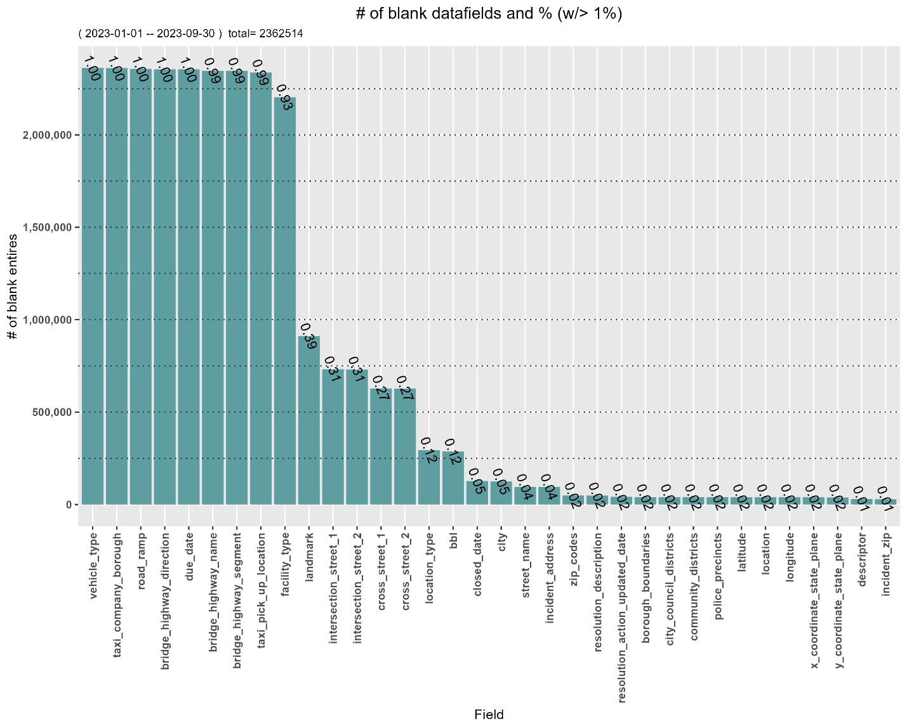

**********VALIDATE DATA TYPES**********

All four date fields have been converted from character to dates.

All non-conforming date field values are represented as NA

Are all 'unique_key' truely unique? TRUE

There are 2 non-numeric, non-5-digit 'incident_zip' entries.

unique_key incident_zip agency

57046995 na DCWP

56867722 N/A DCWP

Ranked by Agency

agency count percentage

DCWP 2 100

All 'zip_codes' entires are 5 numeric digits.

Are all values in 'x_coordinate_state_plane' numbers? TRUE

Are all values in 'y_coordinate_state_plane' numbers? TRUE

Are all values in 'latitude' numbers? TRUE

Are all values in 'longitude' numbers? TRUE

Are all values in 'community_districts' numbers? TRUE

Are all values in 'borough_boundaries' numbers? TRUE

Are all values in 'city_council_district' numbers? TRUE

Are all values in 'police_precincts' numbers? TRUE

**********CHECKING FOR ALLOWABLE, VALID, & LEGAL VALUES**********

The number of 'latitudes' outside the boundaries of NYC is: 0

The number of 'longitudes' outside the boundaries of NYC is: 0

Are all values in 'address_type' valid? TRUE

Are all values in 'status' valid? TRUE

Are all values in the 'borough' valid? TRUE

Are all values in 'borough_boundaries' valid? TRUE

Are all values in 'park_borough' valid? TRUE

Are all values in 'taxi_company_borough' valid? TRUE

Are all values in 'open_data_channel_type' valid? TRUE

Are all values in 'vehcile_type' valid? TRUE

Are all values in 'city_council_district' valid? TRUE

Are all values in 'police_precinct' valid? FALSE

There are 830,708 invalid 'police_precinct' entries

representing 35.76 % of non-blank data,

comprised of 26 different 'police_precinct' entries.

Top 10 invalid 'police_precinct's:

precinct count percentage cumulative_percentage

1 62 58595 7.05 7.05

2 72 56017 6.74 13.79

3 67 49214 5.92 19.71

4 64 44849 5.40 25.11

5 65 41740 5.02 30.13

6 60 39829 4.79 34.92

7 66 37815 4.55 39.47

8 53 36935 4.45 43.92

9 73 36894 4.44 48.36

10 63 36419 4.38 52.74

There are 12,503 invalid 'community_board' entries

representing 0.53 % of non-blank data,

comprised of 12 different 'community_board' entries.

Top Ten invalid 'community_board's:

community_board count percentage cumlative_percentage

64 MANHATTAN 3580 28.63 28.63

83 QUEENS 2215 17.72 46.35

81 QUEENS 1623 12.98 59.33

55 BROOKLYN 1442 11.53 70.86

80 QUEENS 1111 8.89 79.75

26 BRONX 1049 8.39 88.14

28 BRONX 456 3.65 91.79

82 QUEENS 454 3.63 95.42

27 BRONX 192 1.54 96.96

95 STATEN ISLAND 182 1.46 98.42

Ranked by Agency

agency count percentage cumulative_percentage

NYPD 3981 31.84 31.84

TLC 3307 26.45 58.29

DPR 3037 24.29 82.58

DOT 956 7.65 90.23

EDC 498 3.98 94.21

DSNY 196 1.57 95.78

DOHMH 148 1.18 96.96

DCWP 134 1.07 98.03

DEP 120 0.96 98.99

DHS 71 0.57 99.56

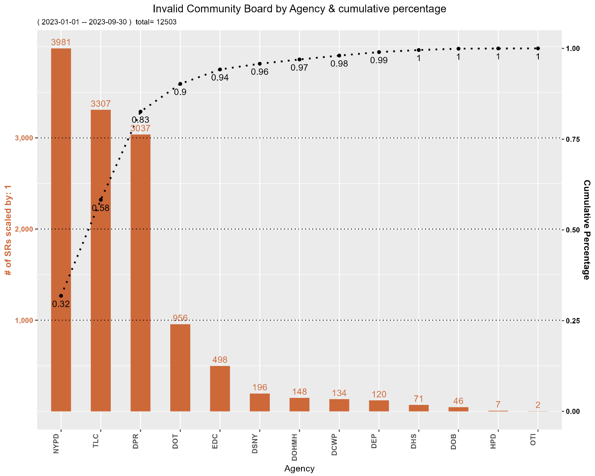

There are 1,525 invalid 'incident_zip' entries

representing 0.07 % of non-blank data,

comprised of 34 different 'incident_zip' entries.

Top 10 invalid 'incident_zip's:

incident_zip count percentage cumlative_percentage

10000 495 32.46 32.46

10121 226 14.82 47.28

10278 169 11.08 58.36

11359 140 9.18 67.54

10103 61 4.00 71.54

10172 49 3.21 74.75

10281 48 3.15 77.90

10120 45 2.95 80.85

11251 33 2.16 83.01

12345 29 1.90 84.91

Top 10 by Agency

agency count percentage cumulative_percentage

NYPD 493 32.33 32.33

DOT 295 19.34 51.67

TLC 246 16.13 67.80

EDC 120 7.87 75.67

DPR 104 6.82 82.49

DSNY 99 6.49 88.98

DOHMH 48 3.15 92.13

DHS 36 2.36 94.49

DCWP 35 2.30 96.79

DOB 26 1.70 98.49

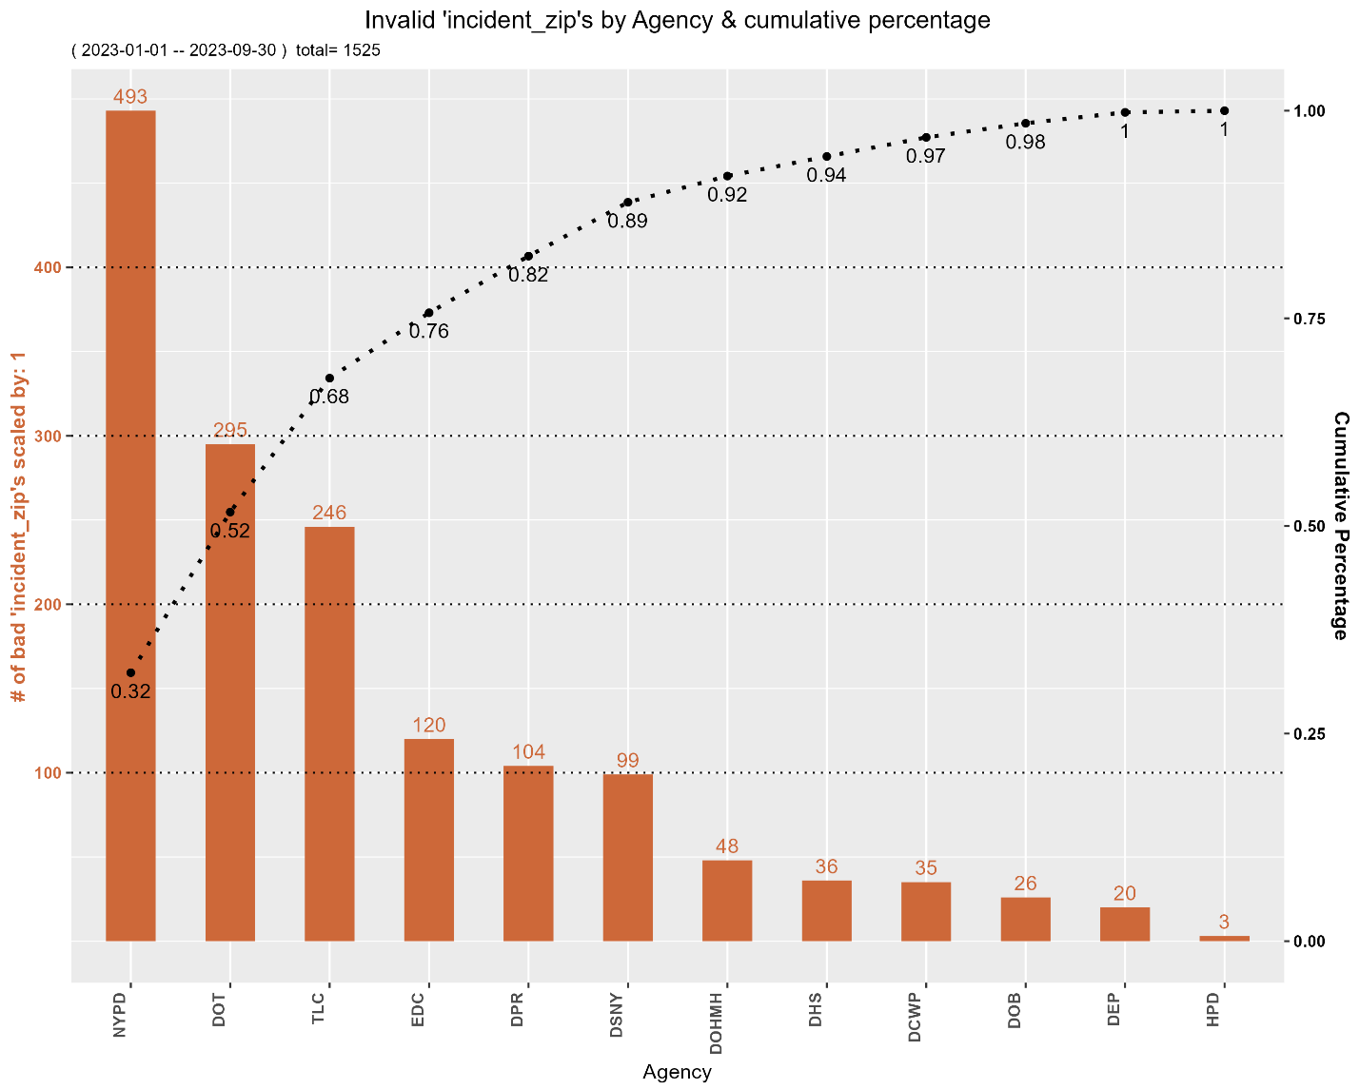

There are 1,305,311 invalid 'zip_codes' entries

representing 56.42 % of non-blank data,

comprised of 140 different 'zip_codes'.

Top 10 invalid 'zip_codes':

zip_code count percentage cumulative_percentage

13510 35438 2.71 2.71

11605 33667 2.58 5.29

11606 32217 2.47 7.76

10935 31822 2.44 10.20

10936 29813 2.28 12.48

17613 29435 2.26 14.74

10934 29348 2.25 16.99

18181 24993 1.91 18.90

11275 24532 1.88 20.78

13829 23067 1.77 22.55

Top 10 by Agency

agency count percentage cumulative_percentage

NYPD 561194 42.99 42.99

HPD 276910 21.21 64.20

DSNY 132147 10.12 74.32

DOT 73514 5.63 79.95

DEP 72670 5.57 85.52

DPR 60502 4.64 90.16

DOB 44102 3.38 93.54

DOHMH 36681 2.81 96.35

DHS 15706 1.20 97.55

EDC 11423 0.88 98.43

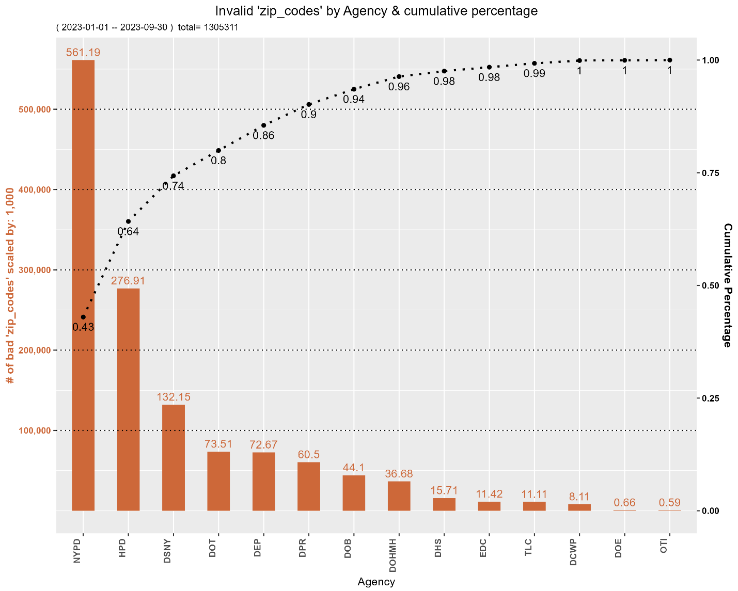

There are 3,550 SRs 'closed' before they were 'created' (negative duration)

representing 0.16 % of non-blank data.

Largest errors (days) *excluding very large negative values:

unique_key created_date closed_date duration agency

56636409 2023-01-27 14:40:00 2022-01-14 14:40:00 -378.000000 DOT

56559854 2023-01-18 10:06:00 2022-01-12 10:06:00 -371.000000 DOT

56636360 2023-01-27 14:36:00 2022-01-22 14:35:00 -370.000694 DOT

56505799 2023-01-11 11:10:00 2022-01-09 11:10:00 -367.000000 DOT

56554327 2023-01-17 11:56:00 2022-06-13 11:55:00 -218.000694 DOT

Smallest errors (days):

unique_key created_date closed_date duration agency

58050416 2023-06-28 07:07:31 2023-06-28 07:07:00 -0.000359 DOT

58061063 2023-06-29 09:10:20 2023-06-29 09:10:00 -0.000231 DOT

56516729 2023-01-12 06:50:13 2023-01-12 06:50:00 -0.000150 DOT

58027895 2023-06-26 08:09:07 2023-06-26 08:09:00 -0.000081 DOT

56521512 2023-01-12 06:51:01 2023-01-12 06:51:00 -0.000012 DOT

Ranked by Agency

agency count percentage

DOT 3541 99.75

DEP 8 0.23

DSNY 1 0.03

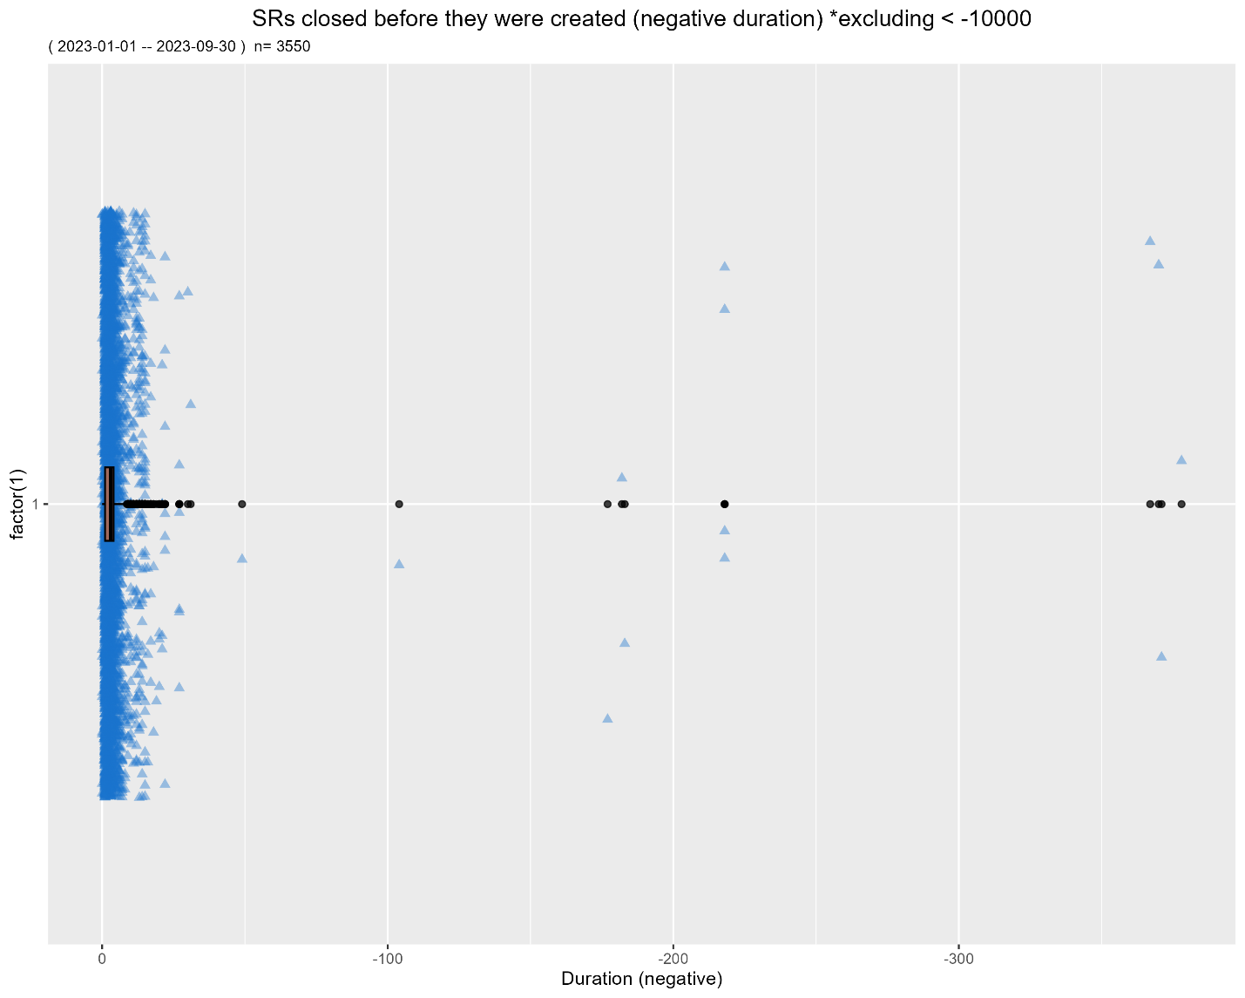

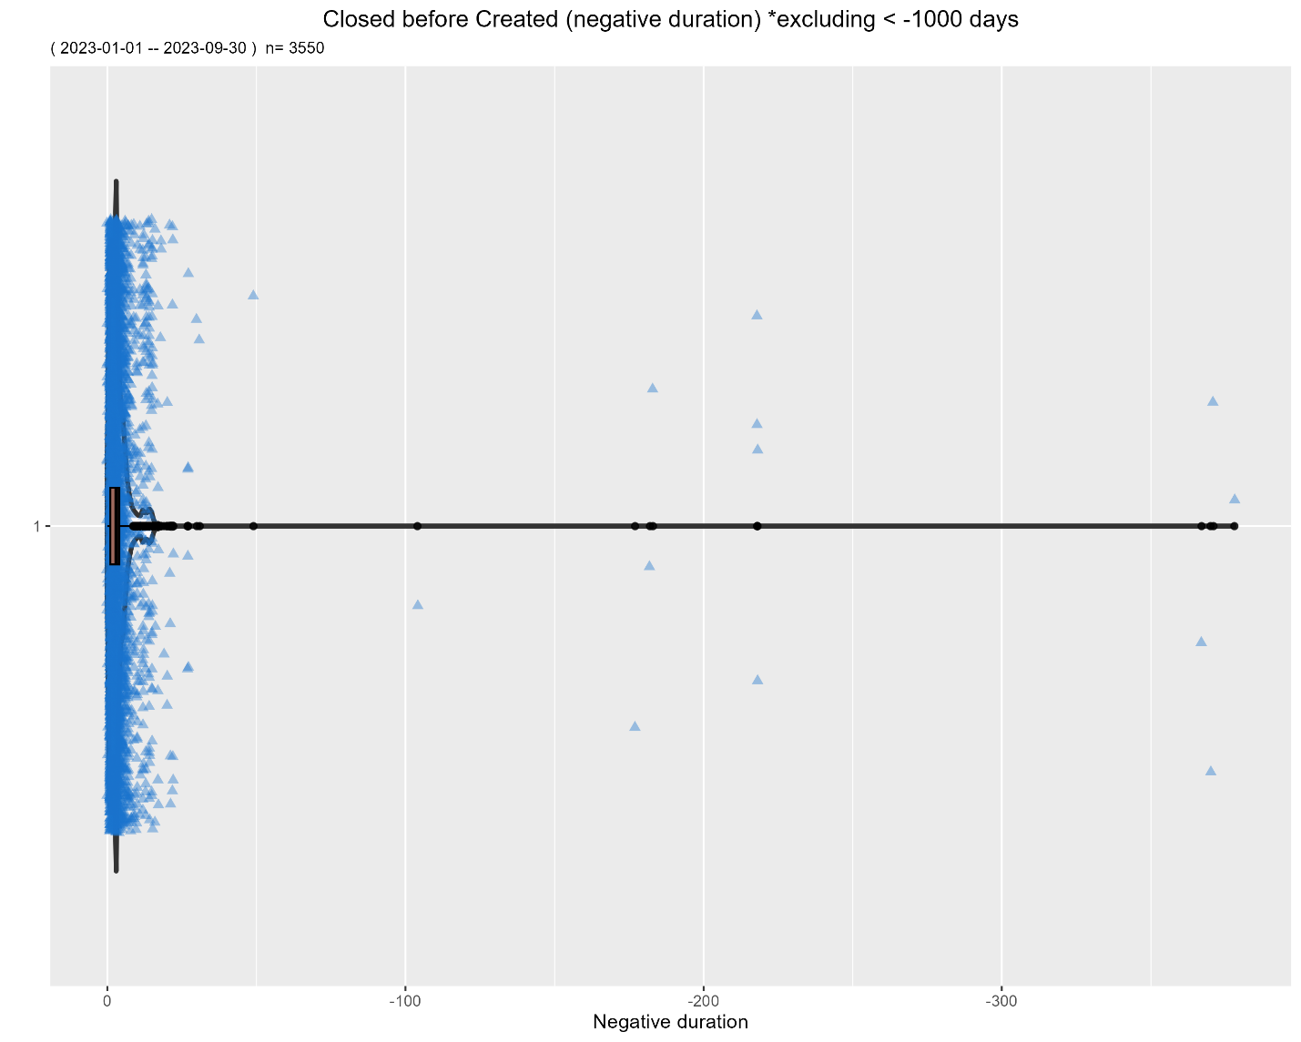

There are 64,207 SRs that were 'closed' and 'created' at the exact same time,

to the second, representing 2.87 % of non-blank data.

Sample of SRs 'closed' at the exact same time they are 'created':

unique_key created_date closed_date duration agency

57628037 2023-05-16 18:13:00 2023-05-16 18:13:00 0 DOT

58410582 2023-08-04 08:53:00 2023-08-04 08:53:00 0 DEP

56854227 2023-02-20 15:01:09 2023-02-20 15:01:09 0 DOHMH

57048015 2023-03-15 13:52:58 2023-03-15 13:52:58 0 DOB

57118703 2023-03-22 09:26:00 2023-03-22 09:26:00 0 DOT

Ranked by Agency

agency count percentage cumulative_percentage

DOHMH 23299 36.29 36.29

DOB 14903 23.21 59.50

DOT 11074 17.25 76.75

DSNY 9211 14.35 91.10

DEP 5070 7.90 99.00

HPD 616 0.96 99.96

OTI 34 0.05 100.01

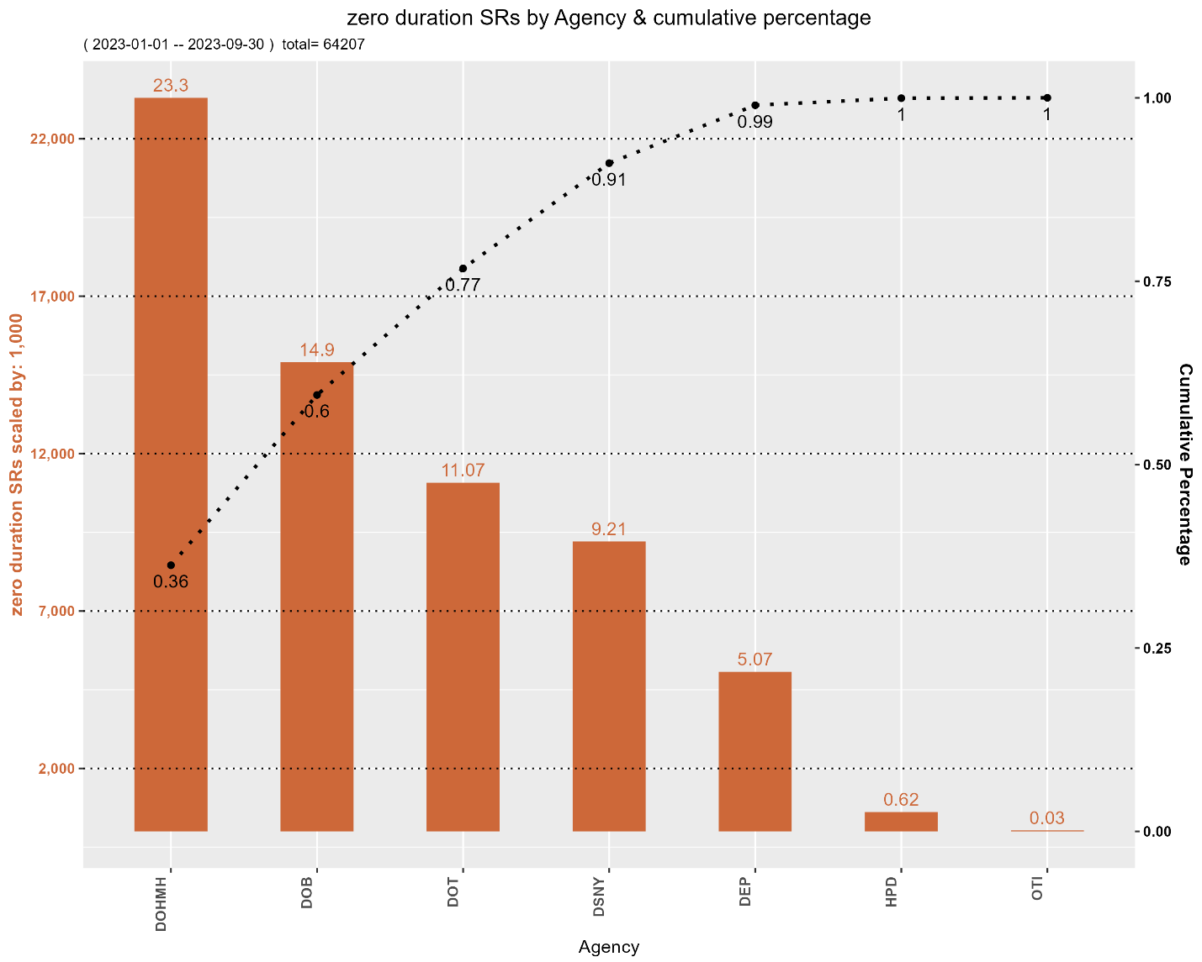

There are no SRs with a 'closed_date' in the future.

There are no SRs with a 'due_date' before 'created_date'.

There are 1,606 SRs with a 'resolution_action_update_date' > 30 day after the 'closed_date',

representing 0.07 % of non-blank data.

Sample of SRs with a 'resolution_action_update_date' >= 30 days after 'closed_date':

unique_key closed_date resolution_action_updated_date postClosedUpdateDuration agency

57320135 2023-06-26 15:54:57 2023-09-29 08:36:30 94.70 TLC

56739684 2023-04-10 12:10:06 2023-10-17 07:50:43 189.82 TLC

57445365 2023-06-16 13:56:20 2023-08-29 11:52:13 73.91 TLC

57294462 2023-07-11 17:36:58 2023-09-21 15:27:11 71.91 TLC

56607134 2023-03-29 11:00:04 2023-07-12 10:15:50 104.97 TLC

Ranked by Agency

agency count percentage cumulative_percentage

TLC 1295 80.64 80.64

DSNY 199 12.39 93.03

DOT 65 4.05 97.08

DCWP 31 1.93 99.01

DOHMH 7 0.44 99.45

DPR 5 0.31 99.76

DOB 3 0.19 99.95

DEP 1 0.06 100.01

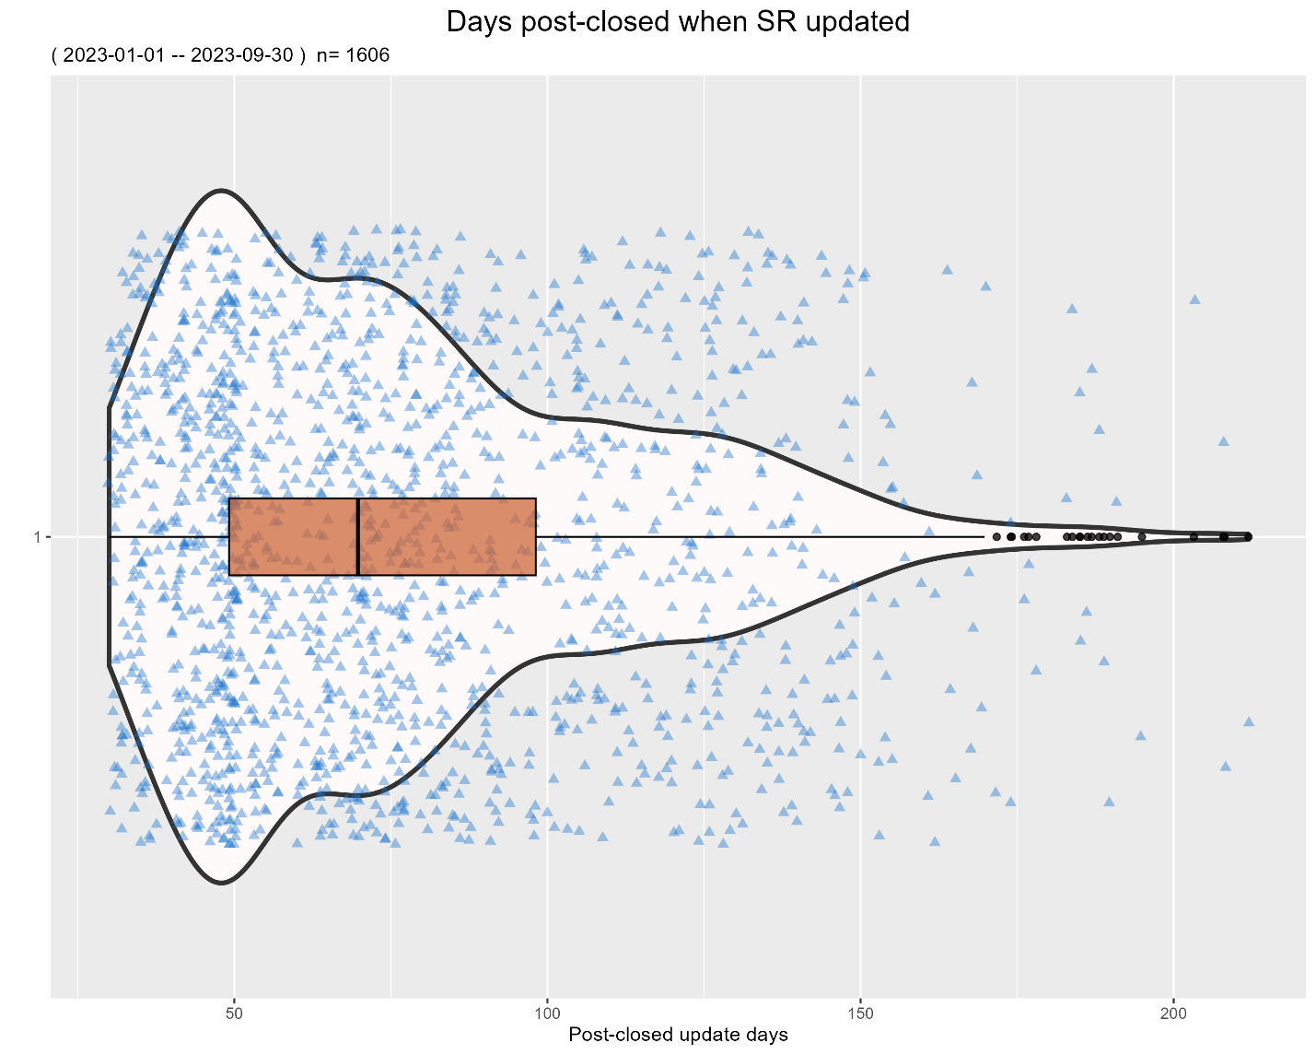

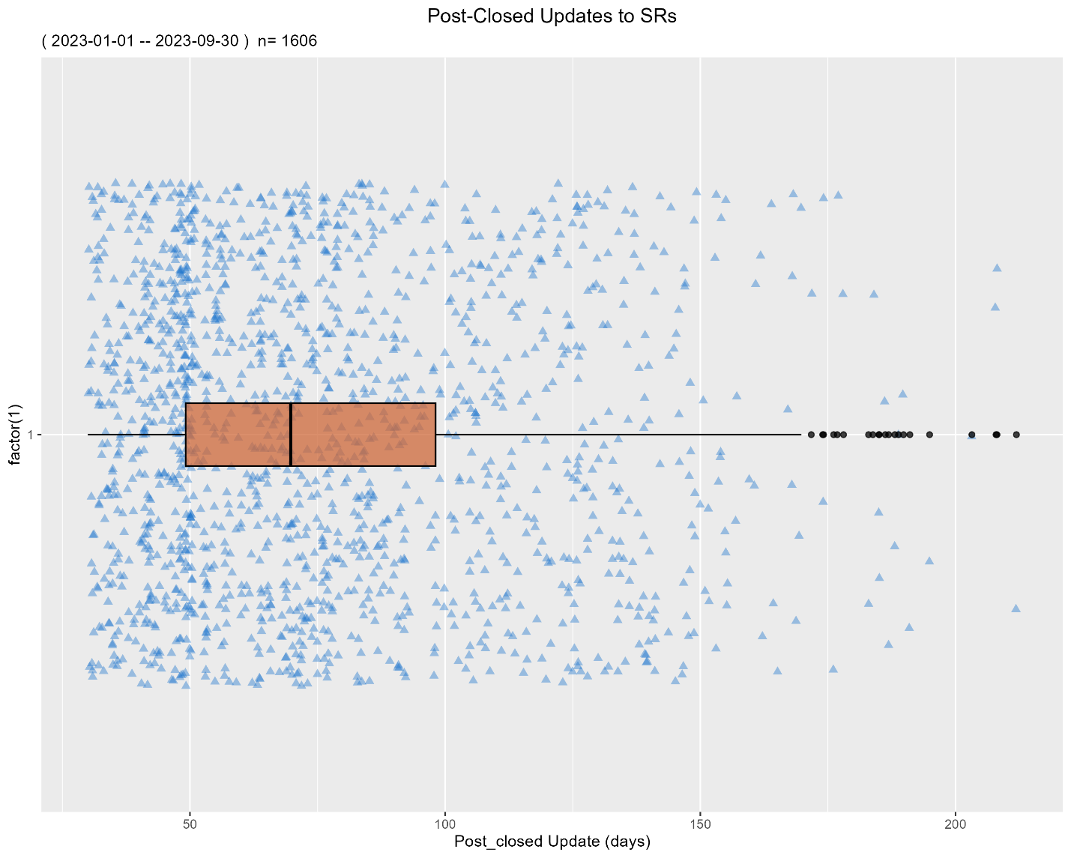

**********CHECKING FOR DUPLICATE VALUES**********

***Comparing Lat/Long and Location. Elapsed time: 7.39

All values of 'latitude' & 'longitude' match the 'location' field.

There are 44,371 non-matches between 'borough' and 'borough_boundaries'

representing 1.88 % of non-blank data.

Sample of the 39482 non-matching between 'borough' and 'borough_boundaries' (where 'borough_boundaries' is blank):

unique_key borough translatedborough_boundaries agency

57196182 BROOKLYN <NA> DOT

58890345 QUEENS <NA> DSNY

56570948 BROOKLYN <NA> DOT

56535076 BRONX <NA> DOT

56961671 BROOKLYN <NA> DOT

56500182 STATEN ISLAND <NA> DOT

58231549 QUEENS <NA> DOT

58177745 QUEENS <NA> DOT

56457010 QUEENS <NA> DOT

57419814 QUEENS <NA> DOT

Sample of the 4889 non-matching between 'borough' and 'borough_boundaries' (where 'borough_boundaries' is NOT blank):

unique_key borough translatedborough_boundaries agency

57586139 BRONX MANHATTAN NYPD

57614462 UNSPECIFIED QUEENS NYPD

58861414 UNSPECIFIED MANHATTAN DOT

58250857 BRONX MANHATTAN NYPD

58097912 BRONX MANHATTAN NYPD

57732762 UNSPECIFIED BRONX NYPD

58865019 UNSPECIFIED MANHATTAN NYPD

58863182 UNSPECIFIED QUEENS NYPD

56495337 UNSPECIFIED QUEENS NYPD

58854857 UNSPECIFIED QUEENS DPR

Ranked by Agency

agency count percentage cumulative_percentage

DOT 22239 50.12 50.12

NYPD 11238 25.33 75.45

DSNY 6161 13.89 89.34

DEP 1558 3.51 92.85

DPR 910 2.05 94.90

TLC 549 1.24 96.14

DOHMH 503 1.13 97.27

DOB 441 0.99 98.26

DHS 350 0.79 99.05

DCWP 271 0.61 99.66

EDC 61 0.14 99.80

HPD 56 0.13 99.93

DOE 22 0.05 99.98

OTI 12 0.03 100.01

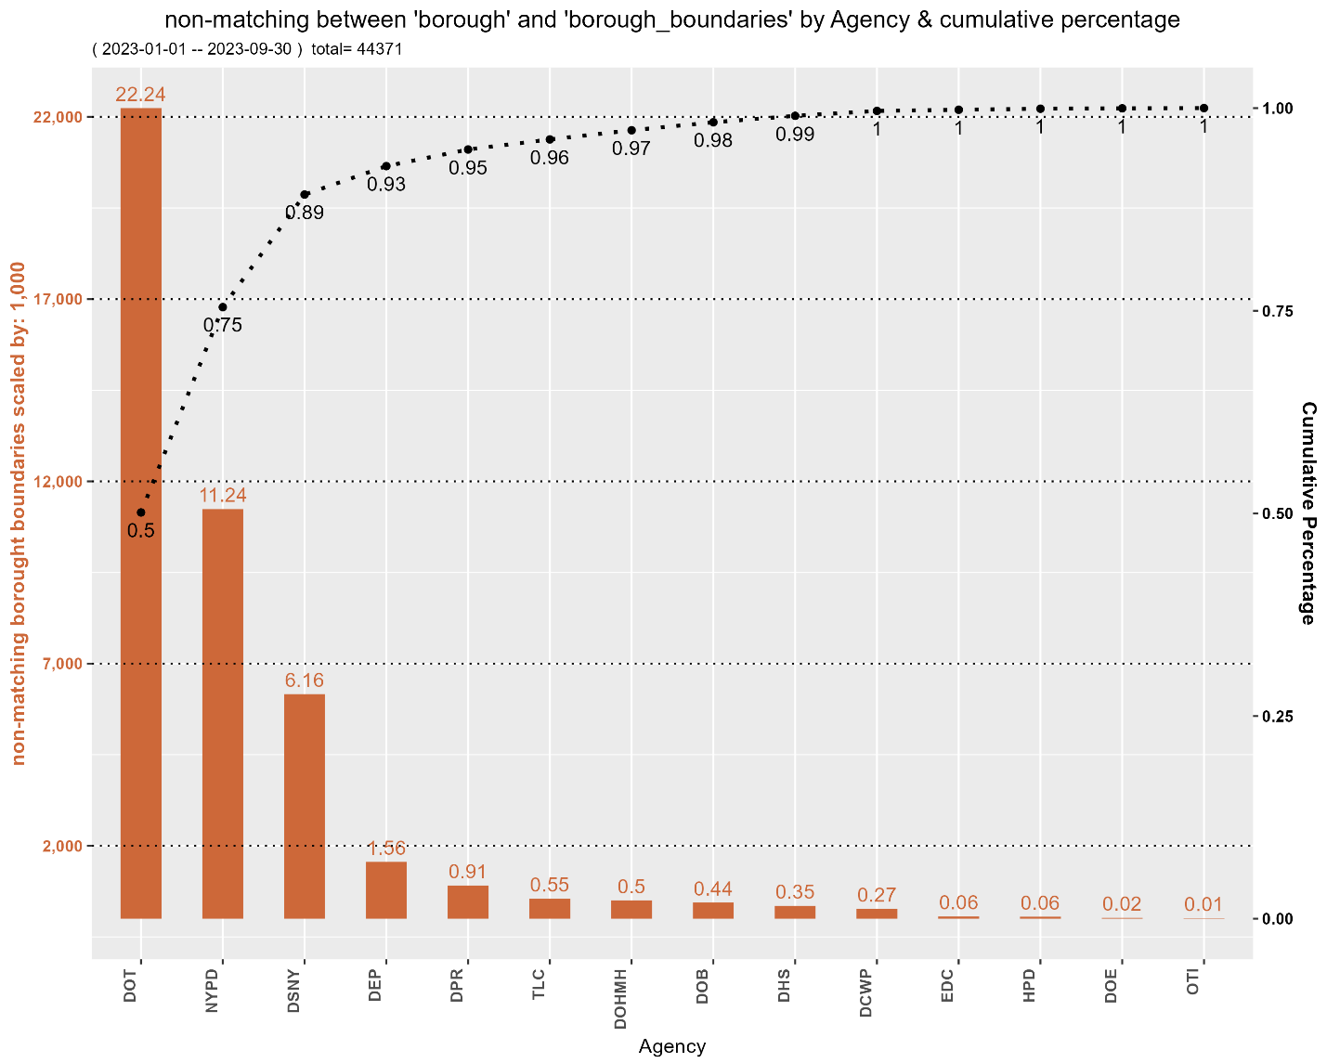

All entries match for columns 'borough' and 'park_borough'.

There are 204 non-matches between 'borough' and 'taxi_company_borough' (excluding blanks)

representing 15 % of non-blank data

Sample of non-matching 'taxi_company_borough' (exluding blanks):

unique_key borough taxi_company_borough agency

56953325 QUEENS BRONX TLC

56721629 UNSPECIFIED QUEENS TLC

58075118 UNSPECIFIED MANHATTAN TLC

57871534 UNSPECIFIED BROOKLYN TLC

57014265 MANHATTAN BROOKLYN TLC

Ranked by Agency

agency count percentage

TLC 204 100

**********CORRECTING COMMON SPELLING ERRORS**********

***Normalizing street names. Elapsed time: 10.85

***Normalizing address fields. Elapsed time: 44.51

***Additional corrections for directions in street names. Elapsed time: 58.98

There are 2,100,837 matching 'cross_street_1' & 'intersection_street_1'

representing 88.92 % of non-blank rows.

Sample of matching 'cross_street_1' & 'intersection_street_1':

cross_street_1 intersection_street_1 agency

115 AVE 115 AVE NYPD

W 63 ST W 63 ST NYPD

MITCHELL PL MITCHELL PL NYPD

11 AVE 11 AVE NYPD

IDLEASE PL IDLEASE PL NYPD

WILLOUGHBY AVE WILLOUGHBY AVE DPR

ALBANY AVE ALBANY AVE NYPD

73 ST 73 ST NYPD

W 179 ST W 179 ST NYPD

82 RD 82 RD NYPD

Ranked by Agency

agency count percentage cumulative_percentage

NYPD 1044360 49.71 49.71

HPD 444050 21.14 70.85

DSNY 181320 8.63 79.48

DPR 104701 4.98 84.46

DOB 74811 3.56 88.02

DOHMH 65984 3.14 91.16

DOT 64917 3.09 94.25

EDC 42902 2.04 96.29

DHS 34770 1.66 97.95

TLC 25439 1.21 99.16

DCWP 16210 0.77 99.93

DOE 1110 0.05 99.98

DEP 180 0.01 99.99

OTI 83 0.00 99.99

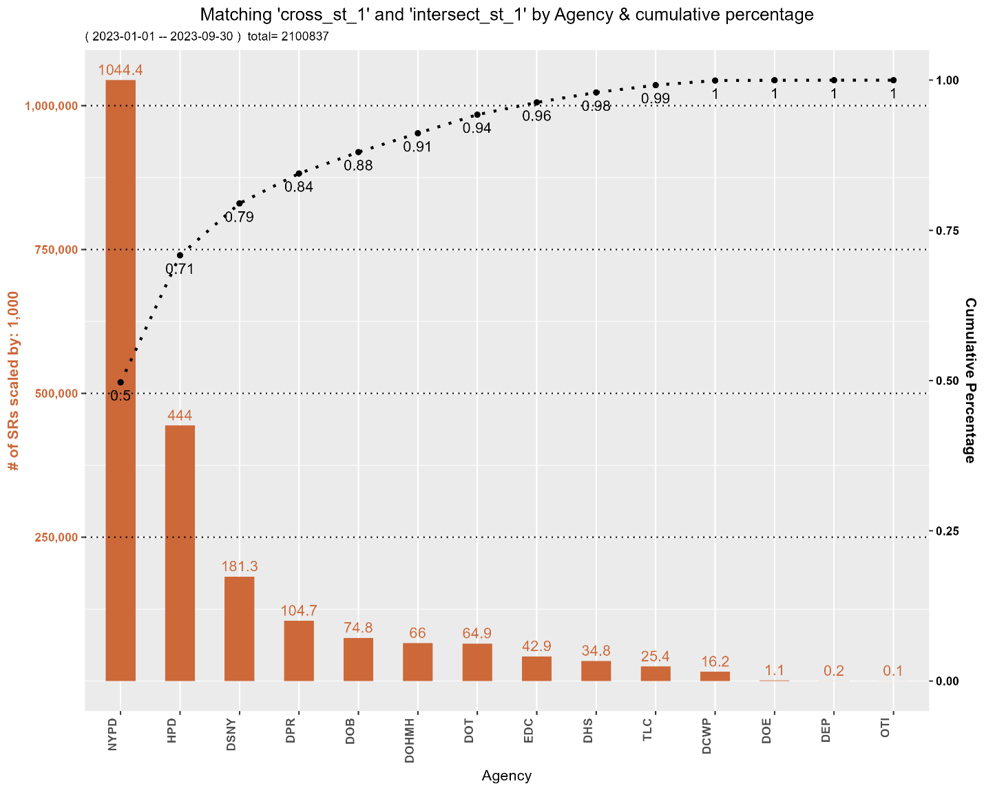

There are 261,677 non-matching 'cross_street_1' & 'intersection_1'

representing 11.08 % of total rows.

Sample of non-matching 'cross_street_1' and 'intersection_street_1':

cross_street_1 intersection_street_1 agency

E 144 ST WILLIS AVE DOT

ROBERTS AVE EDISON AVE DOT

62 AVE 79 ST DOT

W 92 ST COLUMBUS AVE DOT

W 167 ST ANDERSON AVE DOT

BOLTON AVE LACOMBE AVE DOT

HILLSIDE AVE 198 ST DOT

LYME AVE HIGHLAND AVE DOT

KATONAH AVE E 241 ST DOT

DEAN ST SMITH ST DOT

Agencies with non-matches

agency count percentage cumulative_percentage

DEP 127655 48.78 48.78

DOT 85899 32.83 81.61

DSNY 47078 17.99 99.60

OTI 1005 0.38 99.98

DOHMH 40 0.02 100.00

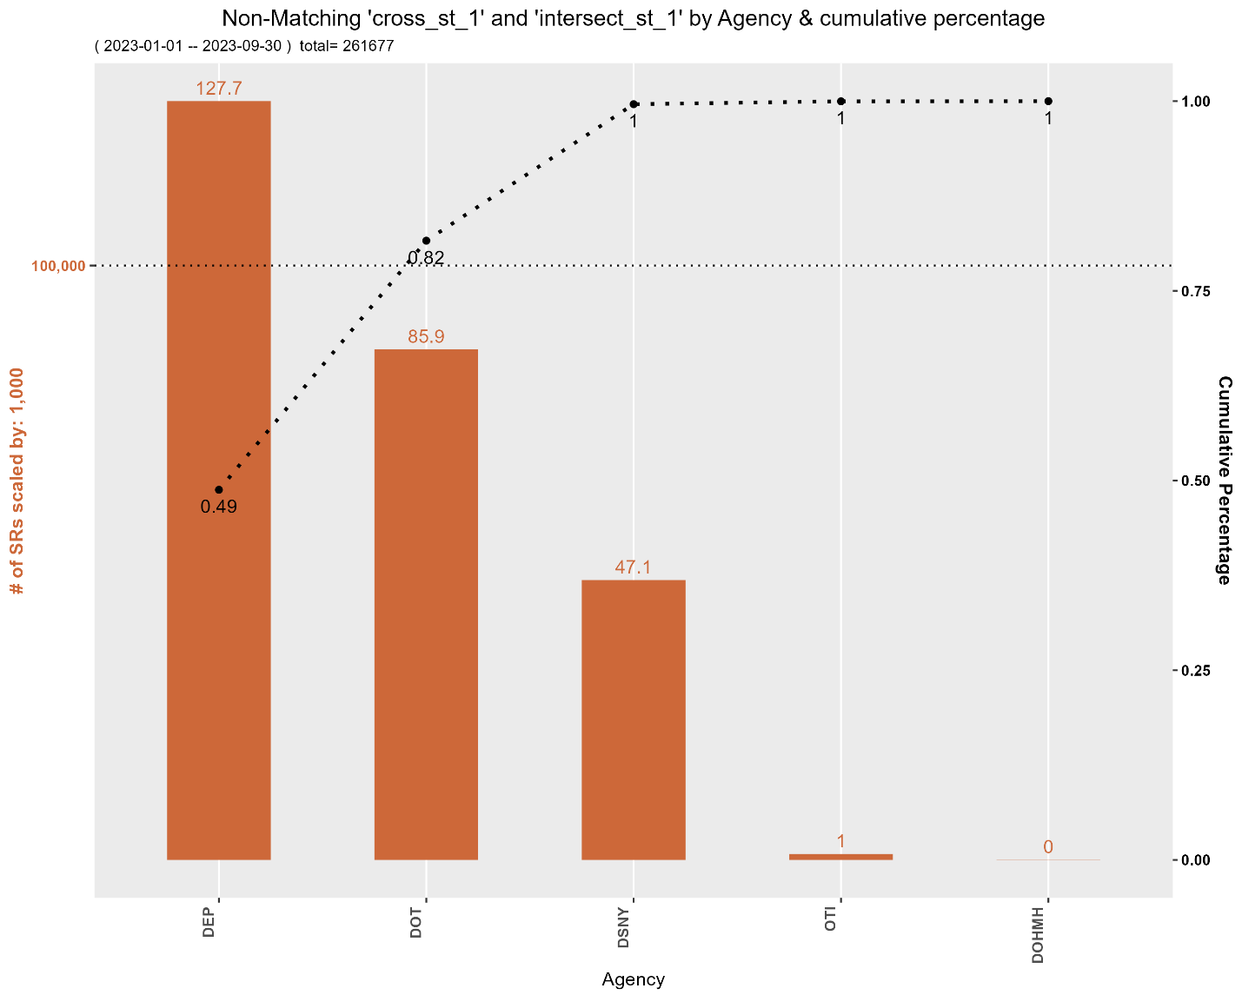

There are 76,017 occurrences where 'cross_street_1' is blank,

but 'intersection_street_1' is not blank representing 3.22 % of total rows.

Sample where 'cross_street_1' is blank but 'intersection_street_1' is not blank:

cross_street_1 intersection_street_1 agency

GRAND CONCRS DOT

LEXINGTON AVE DOT

CENTRAL PARK W DOT

W 171 ST DEP

JAMAICA AVE DOT

LILY POND AVE DOT

CROSS BAY BLVD DOT

37 AVE DOT

MORRIS AVE DOT

CHRYSTIE ST DOT

Ranked by Agency

agency count percentage

DOT 57708 75.91

DEP 14832 19.51

DSNY 3350 4.41

OTI 127 0.17

There are 180,047 occurrences where 'intersection_street_1' is blank,

but 'cross_street_1' is not blank representing 7.62 % of total rows.

Sample where 'cross_street_1' is not blank but 'intersection_street_1' is blank:

cross_street_1 intersection_street_1 agency

BROOKLYN QUEENS EXPY DEP

MAPLETON AVE DEP

LERER LN DSNY

MARCY AVE DSNY

LIRR BAY RIDGE LINE DEP

W 41 ST DEP

BEACH AVE DSNY

FARRAGUT RD DSNY

70 AVE DEP

LA GUARDIA AVE DSNY

Ranked by Agency

agency count percentage

DEP 112822 62.66

DSNY 43728 24.29

DOT 22582 12.54

OTI 878 0.49

DOHMH 37 0.02

Summary of 'cross_street_1' and 'intersection_street_1':

category count percentage

matching 2,100,837 88.92

non-matching 261,677 11.08

X-street1Blank 76,017 N/A

inter-street1Blank 180,047 N/A

There are 2,103,533 matching 'cross_street_2' & 'intersection_2'

representing 89.04 % of total rows.

Sample of matching 'cross_street_2' & 'intersection_street_2':

cross_street_2 intersection_street_2 agency

S 4 ST S 4 ST NYPD

E 96 ST E 96 ST DPR

STUYVESANT AVE STUYVESANT AVE NYPD

BROADWAY BROADWAY NYPD

YORK AVE YORK AVE DOT

BROADWAY BROADWAY NYPD

156 ST 156 ST NYPD

BOWERY BOWERY NYPD

E 180 ST E 180 ST NYPD

E 2 ST E 2 ST DSNY

Ranked by Agency (matching)

agency count percentage cumulative_percentage

NYPD 1044360 49.65 49.65

HPD 444050 21.11 70.76

DSNY 181387 8.62 79.38

DPR 104701 4.98 84.36

DOB 74811 3.56 87.92

DOT 67564 3.21 91.13

DOHMH 65984 3.14 94.27

EDC 42902 2.04 96.31

DHS 34769 1.65 97.96

TLC 25439 1.21 99.17

DCWP 16210 0.77 99.94

DOE 1110 0.05 99.99

DEP 164 0.01 100.00

OTI 82 0.00 100.00

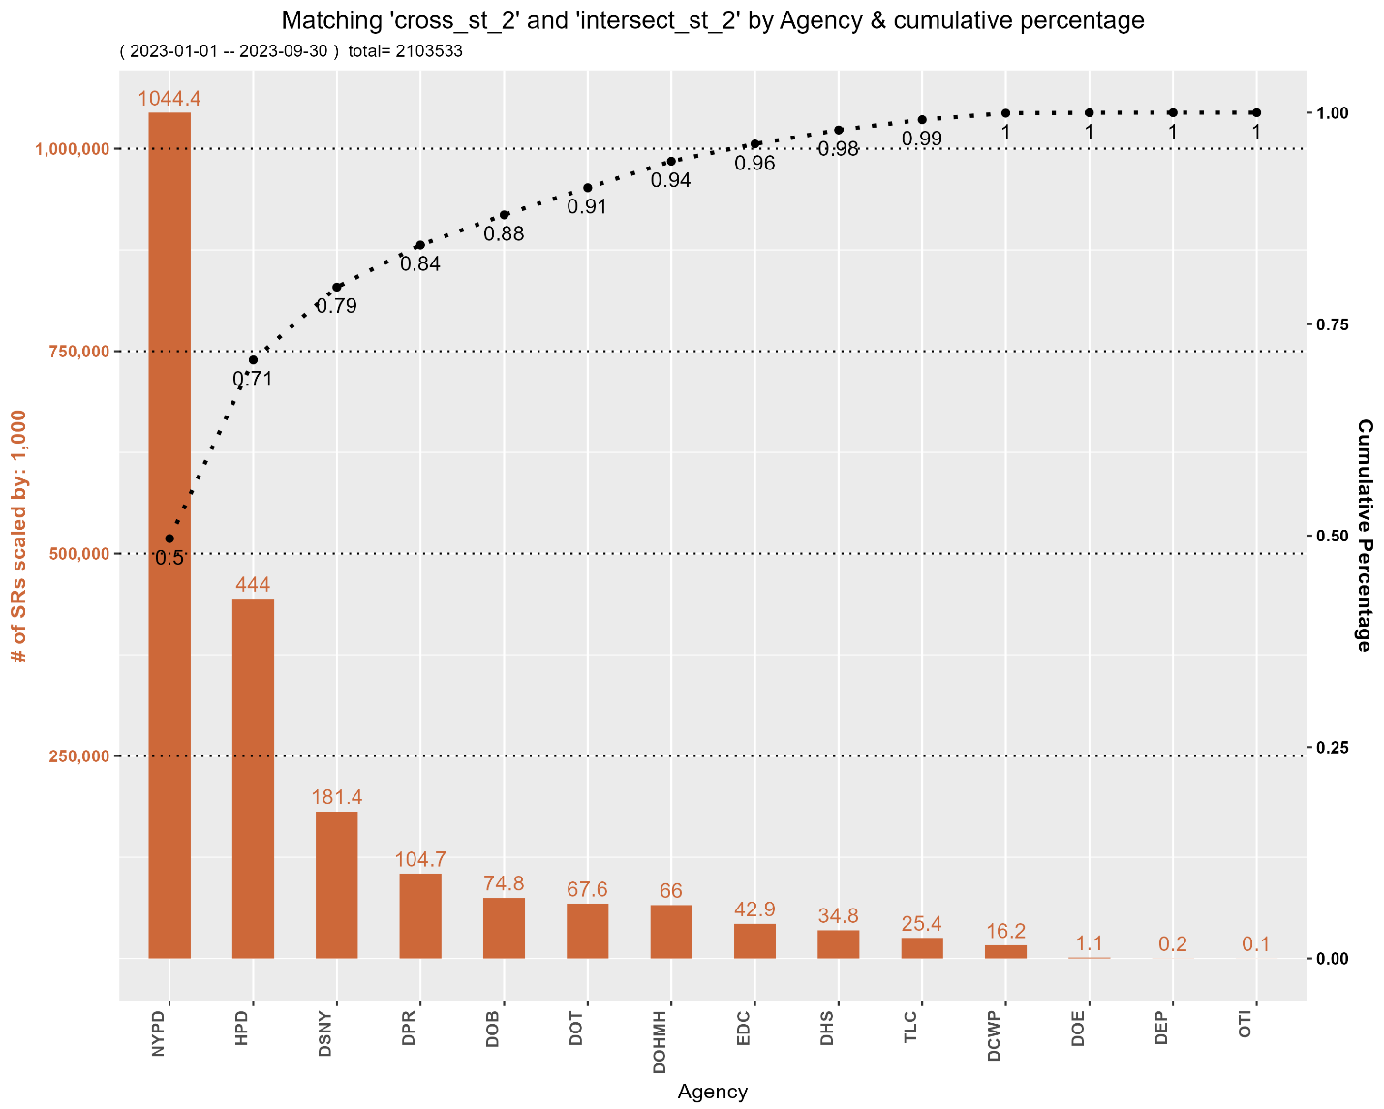

There are 258,981 non-matching 'cross_street_2' & 'intersection_street_2'

representing 10.96 % of total rows.

Sample of non-matching 'cross_street_2' and 'intersection_street_2':

cross_street_2 intersection_street_2 agency

CHRISTIE AVE 97 ST DOT

19 AVE 18 AVE DOT

UNNAMED ST 165 AVE DOT

148 AVE WELLER LN DOT

13 AVE 12 AVE DOT

UNNAMED ST 21 AVE DOT

PROSPECT PL PARK PL DOT

EASTCHESTER BAY PARK DR DOT

GIVAN AVE FISH AVE DOT

ARNOW AVE ALLERTON AVE DOT

Ranked by Agency (non-matches)

agency count percentage cumulative_percentage

DEP 127671 49.30 49.30

DOT 83252 32.15 81.45

DSNY 47011 18.15 99.60

OTI 1006 0.39 99.99

DOHMH 40 0.02 100.01

DHS 1 0.00 100.01

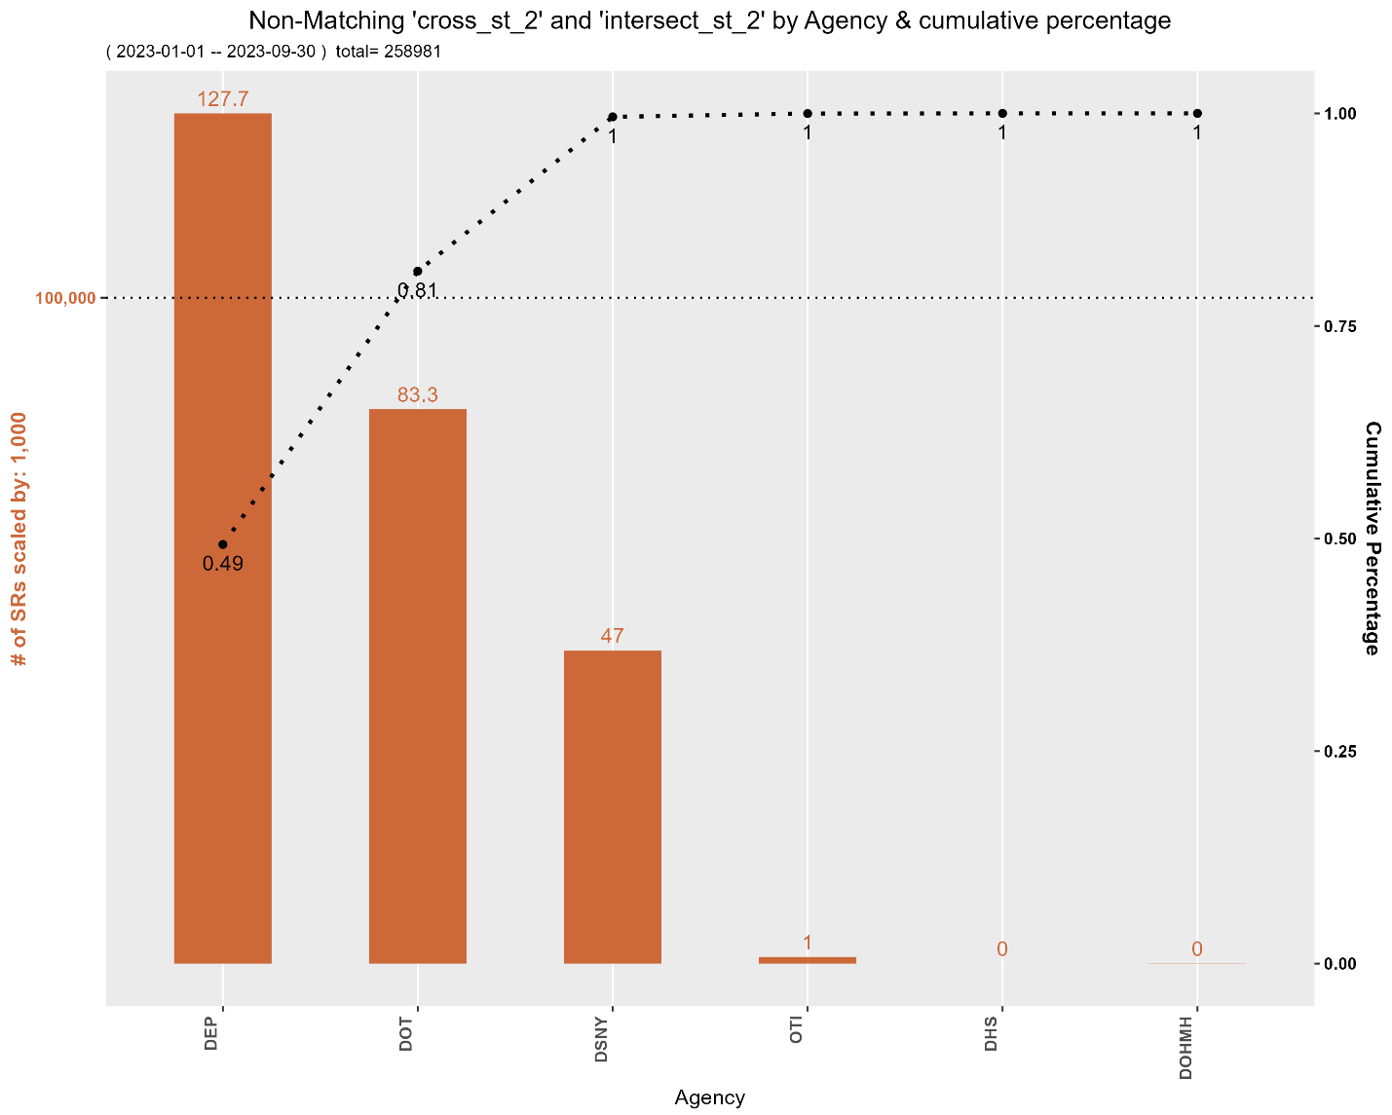

There are 76,101 occurrences where 'cross_street_2' is blank,

but 'intersection_street_2' is not blank representing 3.22 % of total rows

Sample where 'cross_street_2' is blank but 'intersection_street_2' is not blank:

cross_street_2 intersection_street_2 agency

ARTHUR KILL RD DOT

ROCKAWAY BEACH BLVD DOT

W 114 ST DOT

PROSPECT ST DOT

UNION ST DOT

34 AVE DEP

LIBERTY AVE DEP

48 ST DOT

61 ST DEP

125 ST DOT

Ranked by Agency

agency count percentage

DOT 57792 75.94

DEP 14832 19.49

DSNY 3350 4.40

OTI 127 0.17

There are 179,475 occurrences where 'cross_street_2' is not blank,

but 'intersection_street_2' is blank representing 7.6 % of total rows

Sample where 'cross_street_2' is not blank but 'intersection_street_2' is blank:

cross_street_2 intersection_street_2 agency

E 167 ST DEP

10 AVE DSNY

6 AVE DEP

MADISON AVE DEP

KNICKERBOCKER AVE DEP

ARDEN AVE DSNY

58 ST DEP

56 AVE DEP

SUMMIT AVE DEP

W DR DEP

Ranked by Agency

agency count percentage

DEP 112862 62.88

DSNY 43661 24.33

DOT 22036 12.28

OTI 879 0.49

DOHMH 37 0.02

Summary of 'cross_street_2' and 'intersection_street_2':

category count percentage

matching 2,103,533 89.04

non-matching 258,981 10.96

X-streetBlank 76,101 N/A

inter-streetBlank 179,475 N/A

*****A near-match is when the two addresses have no more than 3 characters different.*****

There are 76 near-matches between 'cross_street_1' & 'intersection_street_1'.

Here is a sample:

cross_street_1 intersection_street_1 agency

81 AVE 82 AVE DOT

BAY 22 ST BAY 23 ST DOT

249 ST 253 ST DOT

30 DR 30 ST DOT

85 RD 89 ST DOT

225 ST 226 ST DOT

81 RD 88 ST DOT

N 229 DR E 229 ST DOT

160 ST 163 ST DOT

80 AVE 81 AVE DOT

Ranked by Agency

agency count percentage

DOT 76 100

There are 819 near-matches between 'cross_street_2' & 'intersection_street_2'.

Here is a sample:

cross_street_2 intersection_street_2 agency

217 ST 216 ST DOT

76 ST 75 ST DOT

E 24 ST E 23 ST DOT

9 AVE 8 AVE DOT

6 AVE 5 AVE DOT

163 ST 162 ST DOT

167 ST 166 ST DOT

5 AVE 4 AVE DOT

W 114 ST W 113 ST DOT

8 AVE 7 AVE DOT

Ranked by Agency

agency count percentage

DOT 819 100

Program run-time: 59.97 minutes

*****END OF PROGRAM*****